**MODULE 5) HTML5**

**ASSIGNMENT3.pdf**

**1) what are the new tags added in HTML5?**

|  |  |
| --- | --- |
| **Tags (Elements)** | **Description** |
| <article> | Represents an independent piece of content of a document, such as a blog entry or newspaper article |
| <aside > | Represents a piece of content that is only slightly related to the rest of the page. |
| <audio> | Defines an audio file. |
| <canvas> | This is used for rendering dynamic bitmap graphics on the fly, such as graphs or games. |
| <command> | Represents a command the user can invoke. |
| <datalist> | Together with the a new list attribute for input can be used to make comboboxes |
| <details> | Represents additional information or controls which the user can obtain on demand |
| <embed> | Defines external interactive content or plugin. |
| <figure> | Represents a piece of self-contained flow content, typically referenced as a single unit from the main flow of the document. |
| <footer> | Represents a footer for a section and can contain information about the author, copyright information, et cetera. |
| <header> | Represents a group of introductory or navigational aids. |
| <hgroup> | Represents the header of a section. |
| <keygen> | Represents control for key pair generation. |
| <mark> | Represents a run of text in one document marked or highlighted for reference purposes, due to its relevance in another context. |
| <meter> | Represents a measurement, such as disk usage. |
| <nav> | Represents a section of the document intended for navigation. |
| <output> | Represents some type of output, such as from a calculation done through scripting. |
| <progress> | Represents a completion of a task, such as downloading or when performing a series of expensive operations. |
| <ruby> | Together with <rt> and <rp> allow for marking up ruby annotations. |
| <section> | Represents a generic document or application section |
| <time> | Represents a date and/or time. |
| <video> | Defines a video file. |
| <wbr> | Represents a line break opportunity. |

**2) How to embed audio and video in a webpage?**

**ANS: Step 1:**

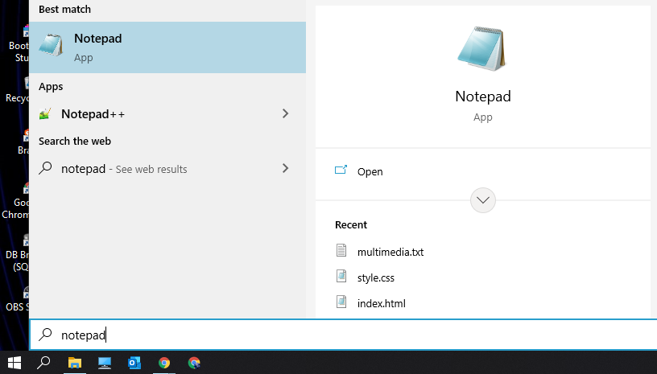

**Step 2:** Save a new file with a valid name following with .html extension.

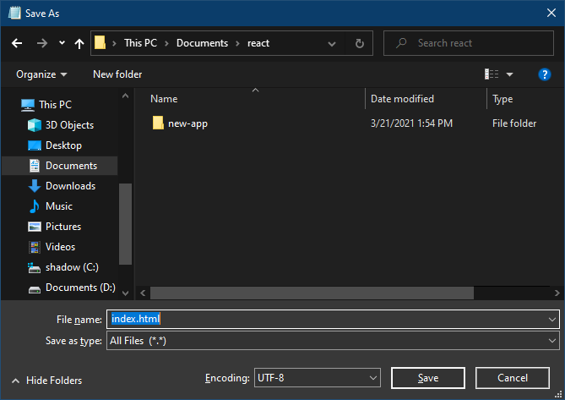

**Step 3:** Once the HTML file is saved, you can write HTML code inside this file. In this example, we have to embed an audio file so first keep ready an audio file and save it in the same directory where your HTML is saved. Then we write HTML code as shown below code snippet following by HTML code format.

* HTML

|  |
| --- |
| <!DOCTYPE html>  <html>  <head>  <title>Page Title</title>  </head>  <body>  <h2>Click play button to play audio</h2>  <audio src="./test.mp3" controls></audio>  </body>  </html> |

**Output:**

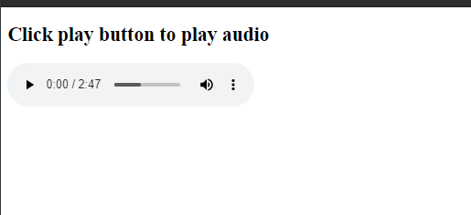

|  |
| --- |
| In this example, we will add a video to our webpage.  <!DOCTYPE html>  <html>  <head>  <title>Page Title</title>  </head>  <body>  <h2>Click play button to play video</h2>  <video src="./test.mp4" controls></video>  </body>  </html> |

* HTML

|  |
| --- |
| <!DOCTYPE html>  <html>  <head>  <title>Page Title</title>  </head>  <body>  <h2>Click play button to play video</h2>  <video controls>      <source  src="./test.mp4">  </video>  </body>  </html> |

**Output:**



**3)semantic element in HTML5?**

Many web sites contain HTML code like: <div id="nav"> <div class="header"> <div id="footer"> to indicate navigation, header, and footer.

In HTML there are some semantic elements that can be used to define different parts of a web page:

* <article>
* <aside>
* <details>
* <figcaption>
* <figure>
* <footer>
* <header>
* <main>
* <mark>
* <nav>
* <section>
* <summary>
* <time>

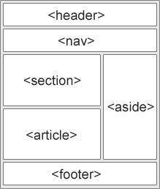

**4) Canvas and SVG tags**

**ANS:** **SVG:** The Scalable Vector Graphics (SVG) is an XML-based image format that is used to define two-dimensional vector-based graphics for the web. Unlike raster image (Ex .jpg, .gif, .png, etc.), a vector image can be scaled up or down to any extent without losing the image quality.

An SVG image is drawn out using a series of statements that follow the XML schema — that means SVG images can be created and edited with any text editor, such as Notepad. There are several other advantages of using SVG over other image formats like JPEG, GIF, PNG, etc.

**Example:**

|  |
| --- |
| <!DOCTYPE html>  <html>    <head>      <style>          #svgelem {              position: relative;              left: 50%;              -webkit-transform: translateX(-20%);              -ms-transform: translateX(-20%);              transform: translateX(-20%);          }      </style>      <title>HTML5 SVG</title>  </head>    <body>      <h2 align="center">          SVG Circle(Geeks For Geeks)      </h2>        <svg id="svgelem" height="200">          <circle id="greencircle" cx="60"              cy="60" r="50" fill="green" />      </svg>  </body>    </html> |

**Output: SVG SQUARE**  
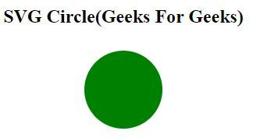

**Canvas:** The HTML element is used to draw graphics on the fly, via scripting (usually JavaScript). The element is only a container for graphics. You must use a script to actually draw the graphics. Canvas has several methods for drawing paths, boxes, circles, text, and adding images.

|  |
| --- |
| <!DOCTYPE html>  <html>    <head>      <title>HTML5 Canvas Tag</title>  </head>    <body>      <h2>Canvas Square(Geeks For Geeks)</h2>        <canvas id="newCanvas" width="100" height="100"          style="border:1px solid #000000;">      </canvas>        <script>          var c = document.getElementById('newCanvas');          var ctx = c.getContext('2d');          ctx.fillStyle = '#7cce2b';          ctx.fillRect(0, 0, 100, 100);      </script>  </body>    </html> |

**Output:**  
